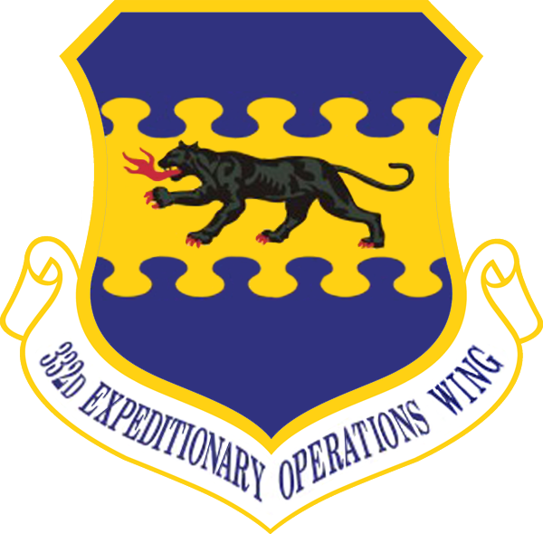
332ND FIGHTER GROUP
Member Handbook
Version 1.09 – June 2026

Introduction
This document outlines the basic rules and knowledge expected of new recruits joining the 332nd Fighter Group. New pilots will begin as prospects, usually for around a month. As a 332nd prospect, you are welcome to take part in larger flyouts, but remember that full members are there to fly and may not always have the capacity to guide you through everything. Recruits will arrive with different levels of experience and understanding, so this handbook sets a common baseline of proficiency. More advanced training will follow as you continue to participate with the group.

Content
Introduction 1
Content 2
The 332nd Way 3
Code of Conduct 3
Setup Requirements 4
In-Game Key Binds 5
Basic Airframe Familiarity 5
Basic Comms 5
Call Signs and Tactical Codes 7
Basic Airfield Procedures 7
Basic Formation and Flight Integrity 7
Formation diagrams 8
Formation turn diagrams 10
10
Assessment Flight (Checkride) 11
Squadron / Group Tags 12
Paint Schemes (Skins) 12
Appendix 1, Brevity Codes 13
Appendixes 20
Appendix: Brevity codes 20
Appendix: Setup tutorials, including SRS/comms, pilot notes, and Haluter skins 20

The 332nd Way
Who we are can be seen in our core values.
- Fun comes first: Fun is why we turn up and why we stay - this is how we have fun:
  - Organised, but relaxed - Structure exists to support good flying, not get in the way of it. This balance is why the 332nd has thrived for over five years.
  - Fly as a team - We plan together, fly together, and look after each other in the air.
  - Clear comms, clear minds - Voice comms belong to the team. Keep calls useful, timely, and concise so we don’t step on our wingmen.
  - Mistakes happen - Nobody gets it right every time. Learn what you can, shake it off, and go again.
  - Culture of camaraderie - Wins are shared, losses are owned together—and yes, it’s ok to die sometimes, just make sure it’s cinematic!
  - Celebrate the wins, laugh at the losses - Good flyouts and bad flyouts both make good stories. Life’s too short to get hung up on a few bad flights.
  - Support each other - Questions are always welcome. Help, training, and advice is never far away.

Code of Conduct
- No personal attacks.
- Members must conduct themselves appropriately in any venue or forum while associated with the 332nd, IL-2, DCS, and related communities. This includes official and unofficial forums for both sims, as well as Discord channels related to the sims or their servers. Remember, when you wear 332nd tags, you represent the entire group.
- Members are expected to fly IL-2 or DCS Warbirds exclusively with the 332nd. Membership in competing groups is not allowed, but participation with other groups for DCS modern aircraft, helicopters, MSFS, and similar activities is permitted.
- Criticism of DCS or IL-2 is allowed. Criticism of another person’s choice of sim is not.
- Organized group flyouts happen each week
  - IL2:
    - FNF: Friday at 6pm Pacific Time / 9pm Eastern Time / Saturday 01:00 Zulu
    - SEF: Saturday at Noon Pacific Time / 3pm Eastern Time / 19:00 Zulu.
    - Pre-flight briefing takes place 30 minutes prior to take-off in the #Briefing channel.
  - DCS:
    - Saturday Fly Out: Saturday at 2pm Pacific Time / 5pm Eastern Time / 21:00 Zulu
- Attendance at weekly flyouts is encouraged, but not mandatory. However, RSVP is required for all active members.

- Pilots unable to attend fly outs or regularly fly with 332nd for an extended period should notify their commanding officer and request to be set “inactive”. Inactive members do not need to RSVP for events. Inactivity is not a punishment, but lack of attendance without requesting an inactive status, or lack of occasional communication/participation while inactive, may result in removal from the group at command’s discretion.
- Pilots removed from the group due to prolonged inactivity can reapply to return at any time. This will result in a 30-day probation period after which a checkride may need to be completed at the discretion of your commanding officer.
- Political and religious chat must stay in the Politics forum. This includes “current events” and political memes. This forum is opt-in and is not accessible by default.
- Upon leaving the group, either by choice or by deactivation, 332nd squadron tags must be removed from Discord groups, forums, IL-2/DCS logins, etc.

Setup Requirements
The following are required for participation in 332nd group flights:
Hardware
- Joystick
- Keybinds/joysticks mapped.
- Working headphones/speakers and microphone.
Software
- Current version of IL-2 Great Battles or DCS installed
- SRS installed and configured. Note that IL-2 and DCS use two separate SRS apps.
  - SRS radios and Discord PTT buttons must be bound to separate binds to avoid double transmissions
  - Prospects must ensure that voice communications can be heard clearly over game and other sounds
  - SRS for IL-2 (Combat Box systems guide , SRS Why and How)
  - SRS for DCS
- Discord
The following are recommended:
- Haluter’s Skin Downloader installed, configured, squadron skins up-to-date (IL-2 only; HSD guide)
- Pilots Notes replacement for cockpit photos (IL-2 only)
Pre-flight: At least 10 minutes before scheduled take-off, log into your sim and verify that stick, throttle, pedals, VR headset/head tracking, radio TX/RX, etc. are all in working order. Flights will not be delayed due to technical issues that do not affect the entire group.
Note: If you are new to IL-2 multiplayer you may be used to “Simplified Controls”, “Simplified Physics”, “Aiming Assist” or other pilot assistance features. These features are not available in 332nd FG multiplayer games. You must handle all aircraft controls on your own and you are required to have all necessary controls mapped or memorized.

In-Game Key Binds
Prospects are expected to know how to set up joysticks, throttles, head tracking, or VR headsets prior to enlisting. Each airframe has its own required bindings for effective operation. This includes, but is not limited to, pitch, yaw, roll, throttle, airscrew pitch or engine speed, landing gear, flaps, radiator or cowl controls, guns, bombs, rockets, and formation lights. These will be discussed in detail at squadron level by your squadron leader. If fine-tuning or airframe-specific questions arise, assistance will be provided on a case-by-case basis.

Basic Airframe Familiarity
Members are expected to have basic competency of piston-engine fighters, both light single-engine and heavier multi-engine airframes. Specific airframe assignments from squadron leaders will suggest further education and mastery. Prior to joining the 332nd you will be expected to be able to complete basic airfield procedures as described later in this handbook.

Basic Comms
Operational communication is critical to the group’s success in all phases of operations and can both win the day as well as spell disaster. We often have 10 to 20 pilots spread across multiple flights. As such the coordination of these flights is heavily dependent on the use of “radios”. Even when flying with small numbers we often take the opportunity to practice these skills.
Two apps are used to simulate radios, SRS and Discord. Between these two apps we have a total of 3 different radios with each radio having multiple channels. IT IS VERY HARD TO LISTEN TO 3 RADIOS; WE DO NOT RECOMMEND IT. Leave that to the CO/XOs.
During the briefing for a mission channels will be assigned for different purposes.
- Command communications, usually SRS 10 in IL2. This is for the wing/mission commander to coordinate the different squadrons. All 332 pilots need to be listening to this channel yet will rarely need to transmit.
- Squadron communications are usually done via a discord comms channel or SRS channel. This is for the squadron leader to organize their flight, and it is the radio pilots will use the most.
- Section communications. Under some rare situations the unused radio will be tuned to an unused channel allowing the section to communicate.
- In IL2 SRS channel 1 has pilots from other groups fighting in the same coalition. This channel is usually used to coordinate multiple groups, and other players may be heard provide callouts of sighted bandits. The Combat Box server has developed a radar controller simulator, either a bot or actual person from Combat Box. This channel will be monitored by the wing/mission commander and squadron leaders.
That’s the background. Pilots are only expected to use two radios at a time, talking and listening to squadron and listening to command. We need pilots to monitor command so that they know when to stop talking and to improve SA.
We have decided to focus on the outcome when setting up your radios rather than prescribing what you do.
- Members must be able to transmit on discord and SRS radios 1 and 2 without double or triple transmitting
- members must be able to listen into at least two “radios” and identify which “radio” a call was received on.
- members must be able to change discord and SRS channels with ease.
How you achieve the above is open – find the best solution for your setup. Many members of the group are happy to help with this, so you’re not alone.
It is imperative that communications are clear, topical, timely and brief. A clogged combat channel can cost lives. Here’s when you are expected to open the channel and transmit:
- When you are asked for information
- When you have critical information to provide
- When you have a critical need for clarity

Idle chatter is never a great idea in combat, and as such is generally frowned upon. However, it is also understood that on longer, uneventful flights (“milk runs”) talking on channel is inevitable. Therefore, every pilot is also expected to be able to silence idle chatter on channel if a combat situation arises. Use the call “CLEAR COMMS!” to indicate the need to clear the radio for subsequent combat-critical information. And know, that if you are on-channel talking about non-combat related topics, you can and will be shut down swiftly if needed. Don’t take this personally, just shut up and get back to working the operation.
Knowledge of standard terms and Brevity Codes are key. With pilots from all corners of the globe, different people may use different terms for the same thing. You will be expected to know and use the codes listed in appendix 1.

Call Signs and Tactical Codes
332nd’s squadrons use the following call signs and tactical codes:
Squadron | Callsign | Default SRS Channel | Tac-Code
100th Fighter Squadron | Panther | 11 | AL-X
No. 226 Squadron | Raider | 12 | MQ-X
334th Squadron | Cobweb | Delta “D” | QP-X
No.486 Fighter Squadron | Kiwi | 14 | SA-X
341st Squadron | Alsace | 13 | NL-X
99th Pursuit Squadron | Cobweb | Delta “D” | QP-X

Each squadron has a specific two-digit tactical code for its members, with the third digit being a uniquely identifiable letter or number assigned to a particular pilot or airframe (e.g. “Kami” in 486th = SA-K. A new prospect in 11th may be “EL-1”). Each pilot’s tac code will be assigned by their commanding officer.

Basic Airfield Procedures
Prospects are expected to have a basic understanding of how to start and run your squadron’s assigned airframes, not necessarily how to maximize the use of the airframes’ settings but at a minimum, start the airframe and maintain it running on the field without delay. Optimal settings will be discussed in further detail at a Squadron level.
To participate in larger flyouts, prospects are expected to follow directions and complete standard airfield tasks without guidance. When assigned to a flight or element, prospects will be required to:
- Start up their airframe (as noted above)
- Taxi and take off as instructed (more detail below)
- Land their aircraft at the designated field (more detail below)
- Clear the active runway (more detail below)

Basic Formation and Flight Integrity
Prospects are expected to be able to fly in formation with their element’s lead ship. Basic proficiency in three primary formation types is required. While formation skills get better over time, basic capability is required to:
- Follow element lead’s instructions during flight
- Remain within visual range of element aircraft during flight, maneuvering, and navigation
- Enter and maintain each of the following formation types:
  - Line Astern (trail)
  - Echelon (left or right)
  - Combat spread (left or right)
  - Combat trail (maintain position anywhere within the maneuvering cone)
- Start and finish formation turns in formation
  - Tactical turn (90 left or right from initiator and follower positions)
  - Cross turn 180
- Follow instructions to perform a rendezvous if separated

Formation diagrams

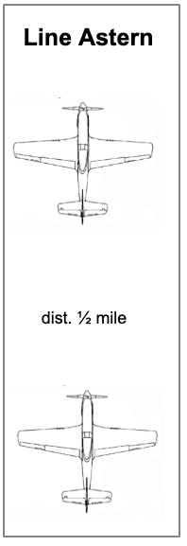
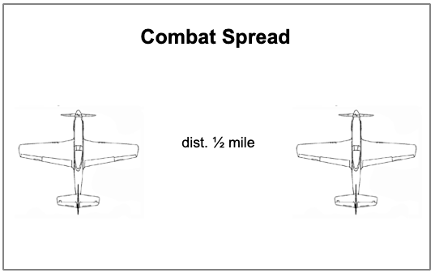
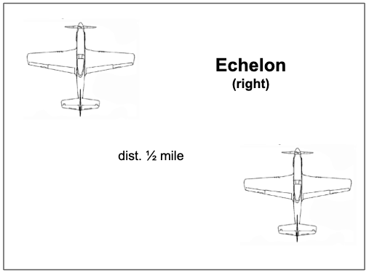

Formation turn diagrams

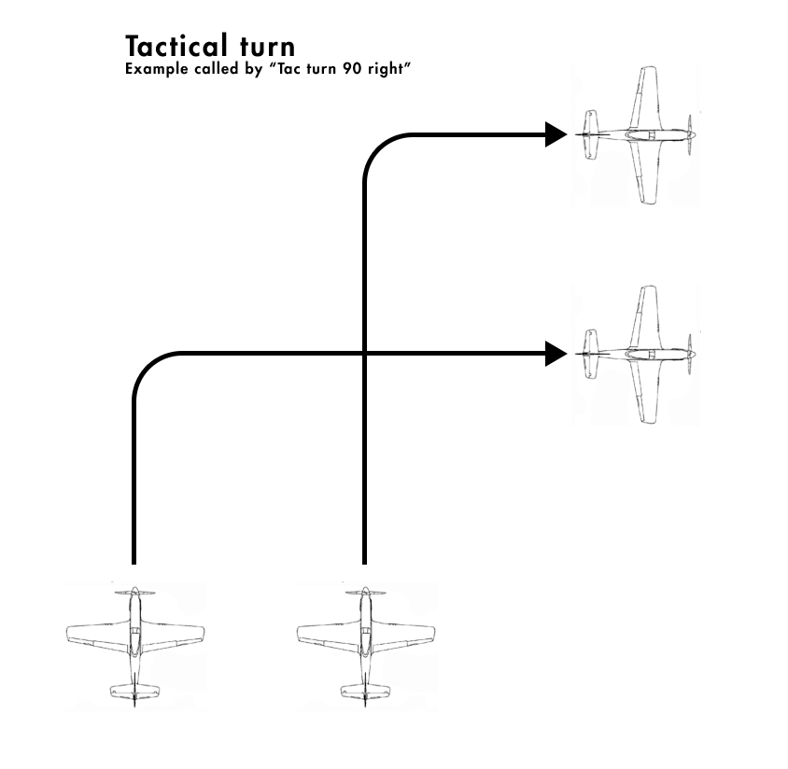







Assessment Flight (Checkride)
All prospects must pass an assessment flight to confirm a solid grasp of these concepts and the ability to function as described above. Generally speaking, checkrides are given after approximately 30 days of becoming a prospect. All prospects must pass their checkride without failure to become a full-fledged member of the group.

Assessment flights will be led by the prospect’s squad leader and will largely proceed as follows:
- Cadet and officer spawn onto the hot ramp
  - Pre-determined
    - Airframe
    - Airfield
    - Loadout
- Perform a verbal “startup flow” covering all necessary controls and procedures for startup.
- Start the airframe and keep it running
- Taxi to the active runway
  - Remain alert for orders to hold short (keep the airframe off of the runway) if required
- Take off
  - Clean up (gear, flaps tucked, canopy closed, formation lights off)
  - Form up quickly
  - Follow officer’s instructions for orbit or egress
- Formation: Enter and maintain each of the following formation types:
  - Line Astern (trail)
  - Echelon (left or right)
  - Combat spread (left or right)
  - Combat trail (Follow lead through maneuvers)
  - Follow instructions to perform a rendezvous if separated
- Formation turns
  - Tactical turn (from the initiator and follower positions)
  - Cross turn
- Navigate
  - Follow officer’s instructions to navigate a circuit
- Simulated attack
  - For fighter/attacker groups: Engaging of drone targets, with the commanding officer first leading in the attack with a handoff to the prospect, and then again on a new target with roles reversed. Ramming is an automatic failure.
  - For bomber/attacker groups: Bombing of a train where the commanding officer leads in the bombing run. Prospect does not need to damage the train but should at least have held formation into the run and dropped when ordered to.
- RTB (return to base)
  - Remain within visual range for base ingress
- Landing and Taxi
  - Follow officer’s instructions for landing pattern
  - Prep airframe for landing
  - Land (do not prang/crash/wreck/ground loop)
  - Follow officer’s instructions to taxi to
    - Clear the active runway
    - Park and shut down airframe

Assessment Automatic Failures:
- Losing Visual contact of flight leader for extended periods more than twice during an assessment.
- Not following directions once being asked to make a correction.
- Causing a flight lead or wingman to have to divert course of travel to avoid a mid-air collision.

Prospects may request lessons on any of the above topics from their commanding officer. Teaching assistance will not be offered during 332nd FG sanctioned events.

Squadron / Group Tags
Only once a prospect has become a full member they shall add their squadron to their Discord name (e.g. “11th CueBall” and the “-332FG-” prefix in IL-2 or DCS (e.g. “-332FG-Cue-Ball").
Prospects are prohibited from using the –332FG- squadron tag in IL-2 or DCS until becoming full members of the group.
Remember, when you display the group tag you are a representative for the entire group. Behave appropriately.

Paint Schemes (Skins)
(IL-2 only) Some squadrons have their own uniquely identifiable paint schemes for various aircraft. Pilots may have custom skins with nose art or other details. Each pilot should download, at a minimum, all skins for their own squadron (preferably all skins for all active squadrons). Commanding officers will determine which skins to use for each aircraft or sortie. Creation of custom skins is the responsibility of each pilot, but there are members of 332nd who are usually willing to create a custom skin. Distribution and download of skins should be done using Haluter’s Skin Downloader (HSD).

Appendix 1, Brevity Codes

Radio codes, used to shorten radio exchanges:
Words marked with an asterisk must be memorized.
Code | Meaning | Example
*ROGER (preferred)  *COPY | I understood your transmission | - We are in grid 0134  - ROGER
WILCO | I understood your transmission and will comply | - Rendezvous over Eindhoven at Angels 9  - WILCO
*THIS IS | My callsign is as follows: | – Hopeless, THIS IS Raider, we are wheels up, circling the airfield  - ROGER

Never use ‘roger’ and ‘wilco’ together. Acknowledge every ‘instruction’ with ‘wilco’, and acknowledge every ‘information’ with ‘roger’. In actuality, ‘wilco’ is rarely used.

Code words used to identify directions and contacts.
Code | Meaning | Example
*CONTACT (preferred)  BOGEY | Unidentified aircraft
FRIENDLY | Friendly aircraft
*BANDIT | Enemy aircraft
TIMES [N] (preferred)  [N]-SHIP  FLIGHT OF [N] | I am reporting N contacts
*O’CLOCK | Used to specify directions with respect to an aircraft. 12 is straight ahead, 6 is directly behind, 9 is off the left wing, etc.
*CO-ALT | Same altitude | - CONTACT, 9 O’CLOCK, CO-ALT, close, same direction  - TALLY
ANGELS [N] | N thousand feet | - I am your 3 o’clock, angels 10
DECK (or ‘on the deck’) | Ground. Refers to aircraft flying very low
FEET WET / FEET DRY | Flying over water / over land | - CONTACT, TIMES three, 11 O’CLOCK, low, medium distance, FEET WET  - NO JOY
*VISUAL (preferred)  *TALLY (preferred)  EYES | I see your reported contact/target/landmark etc.
*NO JOY (preferred)  NO EYES | I do not see your reported contact/target/landmark etc.
Padlocked | Used for leads to indicate they are visually focused on a subject. Their situational awareness will be lowered and they may fly unpredictably to maintain sight on the subject | *Blue 2, I’m padlocked covering Red section, move into combat trail  *Red 2, I’m padlocked on this bogey

NOTE: When giving direction to contacts, follow the following format, if practical:
- The word CONTACT (and TIMES if needed)
- Clock direction. You may say ‘your X O’CLOCK’, or ‘X O’CLOCK of the bombers’, etc. By default use your own aircraft.
- Altitude. Use ‘CO-ALT’, ‘higher’, ‘lower’ or variations. Use DECK, or clouds for reference.
- Distance: Use ‘close’, ‘medium distance’, ‘far’.
- Additional description. For example ‘moving left to right’, or ‘FEET DRY’, or ‘to the left of the lake’.

Think about head movement. First, you turn your head to the right direction (3 o’clock). Then, you need to either raise or lower the eyes (high, low, co-alt). Then, you need to know what size the contact will be (distance). And as you’re already looking there, you get some clarification (i.e. ‘feet wet’, or ‘below clouds’, or ‘over the forest’).

Some good examples of contact reports:
Contact, times 2, 12 o’clock high
- Contact, 2 o’clock, co-alt, medium distance, moving right to left
- Contact, your 6 o’clock, far, on the deck
- Contact, 3 o’clock, above the clouds,

Code words giving flight instructions or commands.
Code | Meaning | Example
*BREAK  (BREAK LEFT/RIGHT) | Perform immediate maximum performance turn in the indicated direction | - You have a 6, break!  - He is diving on you, get ready to break right… break!
*KNOCK IT OFF | Immediately cease all combat maneuvers | - This is a friendly, knock it off!
EXTEND | Fly straight in a shallow descent.  Typically done to disengage, or to increase distance from a pursuing enemy | - Break now! Okay, he’s extending.  - I will make a deflection shot and extend.
DRAG | Lead the enemy in the direction specified.  Can be a part of ‘drag and bag’, where one fighter baits the enemy into a specific position, and another one attacks him. | - He is still on you, drag him down!  - Drag him to the east, I am 10 miles out, looking for you
WAGGLE | Rock your wings | - I see two P-51s, lead, can you waggle?
*RTB | Return to base | - I am winchester, RTB

Glossary: additional terminology used in air combat.
Code | Meaning
WINCHESTER | Out of ammo
BINGO FUEL | Just enough fuel to return to base
SCRAMBLE | Take off as quickly as possible
FURBALL | Multiple contacts maneuvering around each other, likely in a dogfight
FIREBALL | A flying burning aircraft leaving a smoke trail in the sky
CAP | Combat Air Patrol. Fighter mission to remain in the area and maintain air superiority.
Loiter (Ground attack) | A ground attack where the aircraft will loiter for an extended time and make multiple passes on a target
Single pass (Ground attack)  One and done (Ground attack) | A high speed ground attack where the attackers will make one pass on the target and egress immediately at high speed
BOUNCE | A swift attack (usually from above), often on an unsuspecting victim.  Also called ‘boom and zoom’, when the attacker has a large energy advantage.
ON/OFF  (typically “I’m off”, “I’m on”, or “He is off” etc.) | Maneuver to stay at the enemy’s 6 o’clock (“on”), or maneuver away from that position (“off”)  A common way to engage 2v1 is to take turns going ‘on’ and ‘off’ on the enemy:  1: I’m on! Guns! I missed, off.  2: I’m on. Got some hits, I’m off.  1: You’re clear, I’m on.
THROUGH / OVERSHOOT | Fly from the enemy’s rear to the front, crossing his 3-9 line (from 6 o’clock to 12 o’clock).  “He is diving on you, break. Okay, he’s through. He’s climbing back, extend”.
DEFLECTION (or ‘deflection shot’) | A gun attack from a very high aspect (from the side). Typically results in a very short burst, and none or a very few hits.  On the other hand, the attack from the 6 o’clock position allows for longer bursts and a better opportunity to correct the aim
MERGE | Refers to 2 aircraft moving towards each other so that they pass close to each other (not close enough to collide, but closer than gun range)
HEAD ON | A kind of merge when two aircraft fly directly towards each other. Typically in a combat situation, where both try to place a quick ‘head-on shot’ before they merge.
MIDAIR | A collision of two aircraft in the air.

Pronouncing numbers like a pro.
- Headings: use three digits. “Turn left zero nine zero”
- When giving large changes of course the direction of turn should be given - e.g. "Vector right two eight zero", meaning "Turn right to reach a magnetic course of 280 degrees".
- Speeds: use full (typically 3-digit) number: “two hundred eighty”.
  - Clarify mph/kph only when mixing Russian and non-Russian planes.
- Altitudes: use ‘angels N’, or ‘N thousand’, never both. For the number N, use normal numbers: ‘fourteen’, not ‘one four’.
  - Clarify ‘feet’ or ‘meters’ only when mixing Russian and non-Russian planes.
  - ‘Angels’ are always thousands of feet, in Soviet Russia there are no angels.
- Map sectors: use two pairs of 2 digit numbers “Grid ten fourteen”, or “Grid oh-seven oh-nine”.
- Distances: pronounce full number, followed by ‘miles’ or ‘kilometers’: “We’re about twenty three miles out”. Do not use ‘clicks’ or ‘mikes’.

Channel étiquette for 2-ship.
- Don’t use callsigns at all, since you are the only 2 people talking.
- Don’t even use jargon, unless you want to practice brevity. Remember, brevity codes are to keep the channel clean.

Channel etiquette for flight-level comms with more than 2 aircraft.
- You may be assigned a number. Lead is 1, the wingmen are 2, 3, etc.
- You may be assigned a color. Lead is white 1, wingman is white 2, second element are red 1 and red 2, and so forth.
- You can assume that all communication is either BY lead, or directed AT lead.
- Shorten acknowledgements: rather than “Lead, this is Two, Roger”, just say: “Two”.
- Lower numbers should acknowledge first: don’t rush to say “Three” before “Two”. Then again, if Two is silent, after a bit you can say “Three”.

Channel etiquette for inter-flight comms
- For the first call, always use the formula “You, THIS IS me, here’s my message”
- To respond, begin with “You”, no need to say “THIS IS”.
- After the first response, no need for callsigns: you have the channel to yourselves.
- Keep the exchange short and to the point - everyone is listening, and the channel can be busy.

Document history.

2022 OCT 24 – First “beta” revision.
2022 OCT 25 – Major brevity code changes based on Zruty’s feedback.
2022 OCT 26 – Version 1.0. Grammar fixes. SRS channel info. Link to EggNog’s SRS video.
2022 OCT 29 – Version 1.01. Added joystick requirement, paragraph on pilot assistance options.
2022 OCT 31 – Version 1.02. Added link to Pilots Notes IL-2 mod. Separated requirements list into “required” and “recommended”. One bullet point added to flight-level comms.
2022 NOV 04 – Version 1.03. Added details for FNF and SEF and requirement to RSVP.
2023 JAN 07 – Version 1.05. Separated events out by relevant simulator
2023 FEB 12 – Version 1.06. Updated 100th details. Updated Pilot Notes link.
2023 MAR 20 – Version 1.07. Replace LOA with Inactive.
2024 DEC 01 – Version 1.08. Add 99th callsign and details.
2026 JUN 01 – Version 1.09. New brevity codes, com requirements, formations and updated check ride requirements

Setup One
I’m one of those silly people who try to listen to 3 conversations at once. If I need to I turn a radio off by changing the channel to one that is quiet.
4 buttons on my flight stick are used as PTT for discord, SRS com 1, SRS com 2 and voiceattack.
SRS settings are so that com 1 is only heard in my left ear (it’s PTT is also on the left) and com 2 in my right ear. After logging into the server I open the toggle radio overlay and adjust the top (COM 1) volume to 50ish%. I have “Radio Switch works as PPT on. I have a rotory encoder (2 buttons) to change the channel of the active COM.
To change the channel I press the PTT with selects the radio then turn the encoder to press the buttons linked to changing channel up and down.
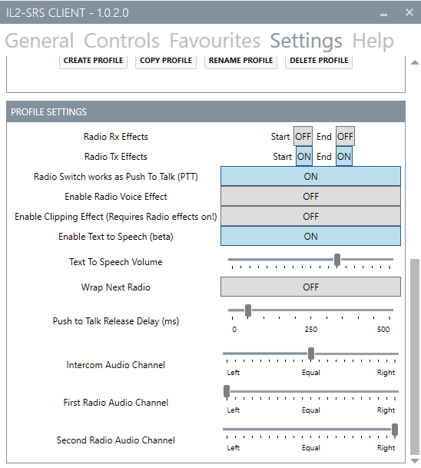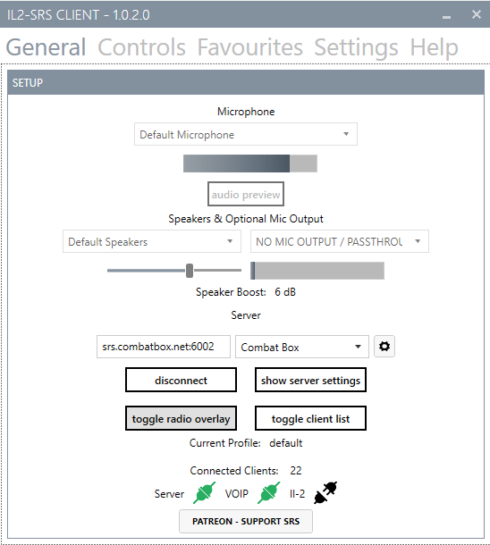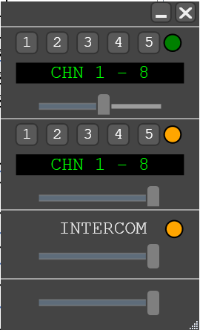
In discord I have keybinds to change channels. Discord is in both ears.
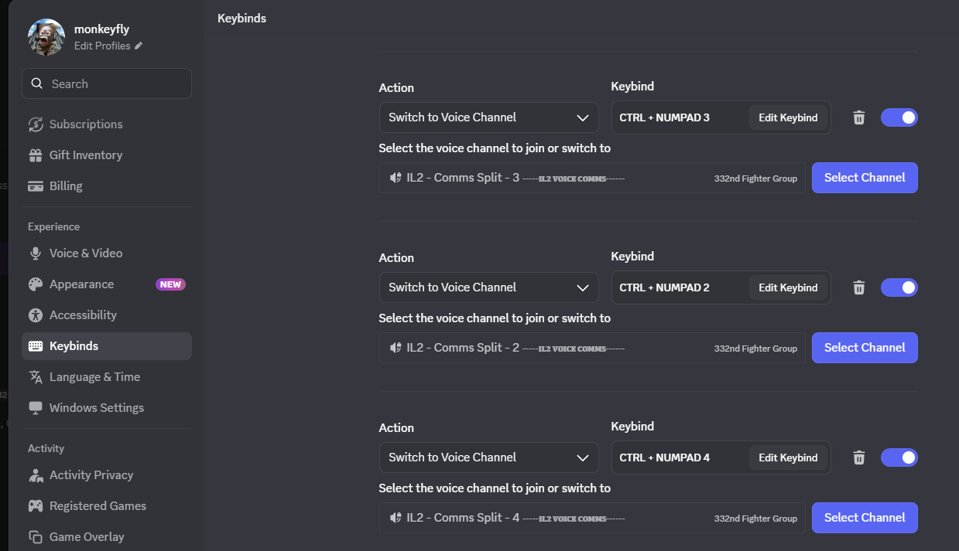
Then I use voiceattack to activate that keybind.
